**Assignment 2**

Create VPC with two instances, one in public subnet and one in private subnet. From EC2 instance in public subnet , connect with EC2 instance in private subnet. Then from private subnet EC2 instance ,upload a file to S3 bucket.

Screenshots :

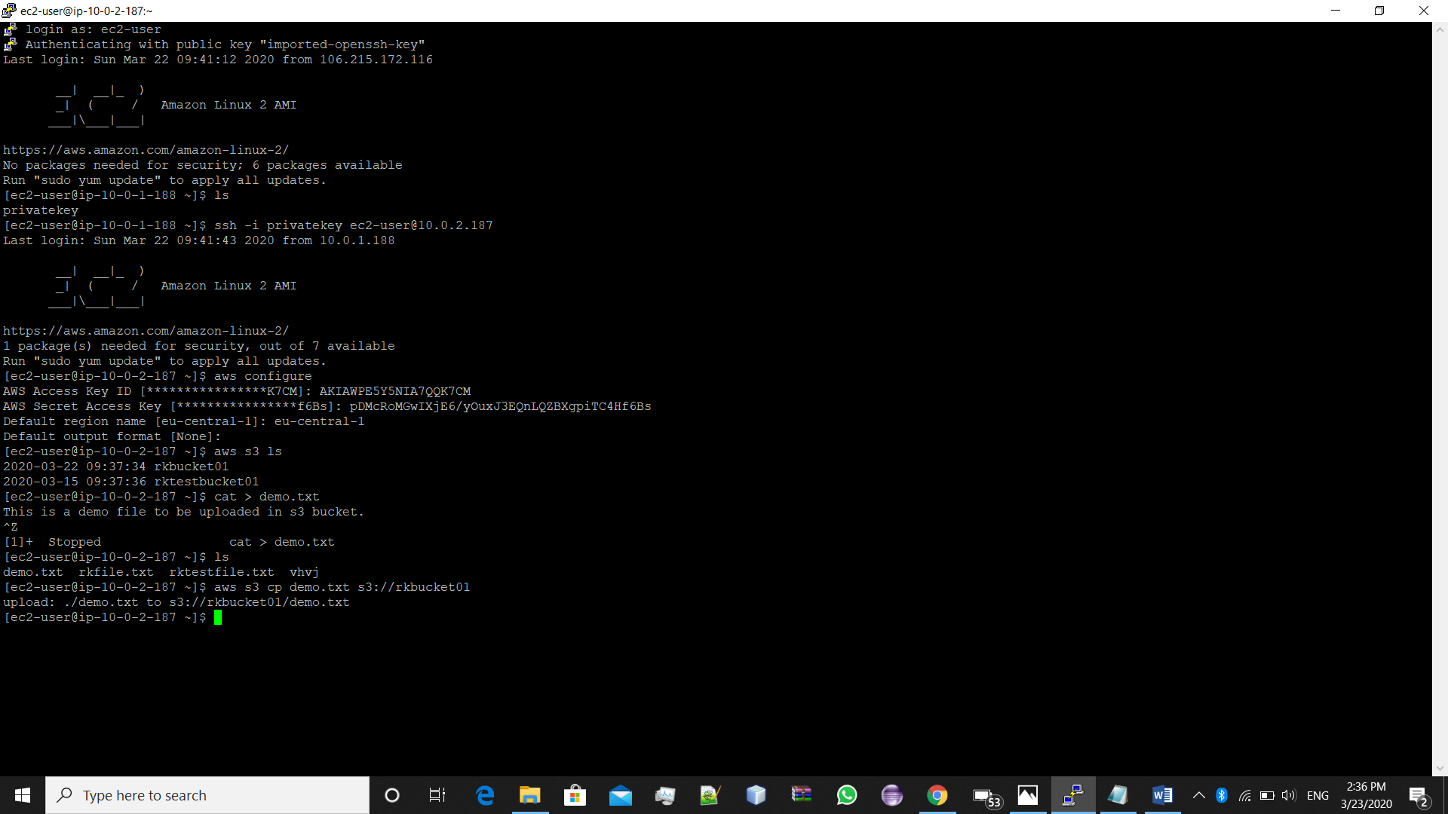

S3 bucket screenshot

